A Comprehensive Guide to Traumatic Brain Injury (TBI): Symptoms, Causes, and Treatment-H1
Author- Dr. Rakesh Ranjan, Sr. Consultant & Director Neuro Sciences
Priority | Search Volume | Keyword Intent | ASV
P1 | Head Injury | Informational | 18100
P1 | Traumatic Brain Injury | Informational | 5400
P1 | TBI | Informational | 6600
P1 | Traumatic Brain Injury Symptoms | Informational | 1000
P1 | Traumatic Brain Injury Treatment | Informational | 590
P1 | Traumatic Brain Injury Surgery | Informational | 480
P2 | Types of Traumatic Brain Injury | Informational | 480
P2 | Traumatic Brain Injury Causes | Informational | 320
P2 | Traumatic Brain Injury Treatment | Informational | 590
P3 | Neurologist in Pune | Business | 3600

Title : Traumatic Brain Injury: Types,Symptoms,Causes and Treatment
Description : Traumatic Brain Injury (TBI) is a serious condition caused by head trauma. Understand its symptoms, causes, types, and treatment options for better care.
Slug-/traumatic-brain-injury
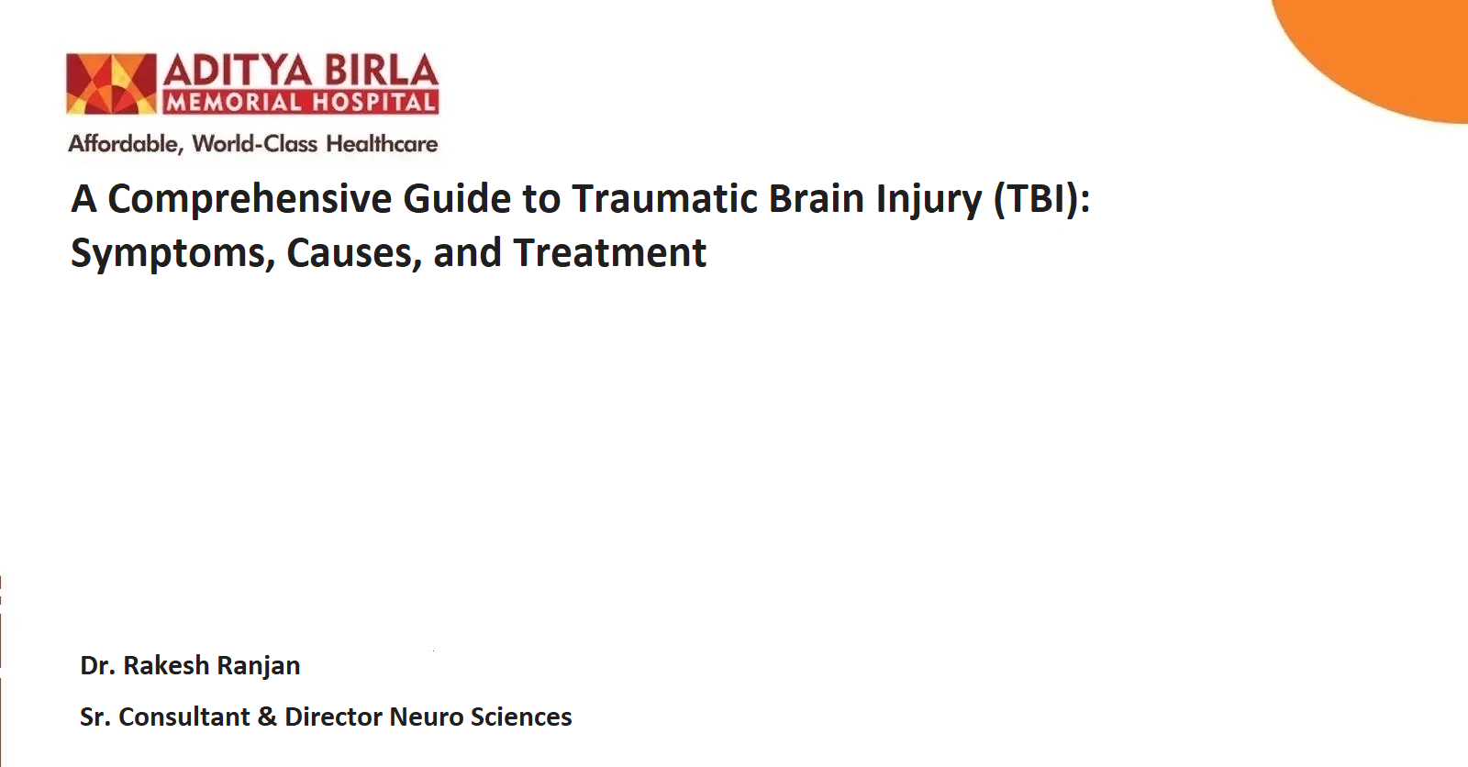

Traumatic Brain Injury (TBI) is a serious medical condition caused by external force to the head, often leading to temporary or permanent impairment. Depending on the severity, TBI can range from mild concussions to severe brain damage.
Understanding traumatic brain injury symptoms, its causes, and available treatments, including traumatic brain injury surgery, can aid in timely intervention.
There’s is no debate that a momentary loss of balance, a car accident, or a sudden blow to the head can be serious. However, a head injury in these cases can lead to issues that are more serious than many can imagine.
This guide explores types of traumatic brain injury, its causes, treatment options, and when to seek medical advice.

What is Traumatic Brain Injury (TBI)?-H2
Traumatic Brain Injury (TBI) refers to damage to the brain caused by external mechanical force. It often results from falls, vehicle accidents, or violent impacts. TBI is classified into different categories based on its severity, the location of the damage, and the type of injury.
A mild TBI, often referred to as a concussion, may cause temporary disruption in brain function. Severe TBI, however, can result in long-term cognitive, physical, and emotional impairments.

Types of Traumatic Brain Injury-H2
Understanding the types of traumatic brain injury is essential for determining the appropriate course of treatment. These include:

1. Concussion-H3
A concussion is a mild form of traumatic brain injury (TBI) where a sudden blow to the head affects brain function temporarily. It can cause headaches, dizziness, and difficulty concentrating. Though usually not life-threatening, a concussion should be taken seriously, as repeated concussions can lead to long-term problems like memory loss.

2. Contusion-H3
A contusion is a bruise on the brain caused by a direct hit to the head. This can lead to swelling, bleeding, and increased pressure inside the skull, sometimes even causing the brain to shift. It’s a more serious injury than a concussion and may require treatment like surgery if the swelling becomes severe.

3. Penetrating Injury-H3
A penetrating injury happens when an object, like a bullet or sharp piece of debris, pierces the skull and enters the brain. This can cause significant damage to brain tissue and may lead to infections. Treatment involves surgery to remove the object and stop bleeding.

4. Diffuse Axonal Injury (DAI)-H3
Diffuse axonal injury (DAI) occurs when the brain shifts rapidly inside the skull, tearing nerve fibers. It often results from car accidents or falls and can lead to a coma or permanent brain damage. Recovery can be long and challenging.

5. Hematomas-H3
Hematomas are blood clots that form in the brain after an injury. They can increase pressure on the brain, causing severe complications. Types include epidural, subdural, and intracerebral hematomas, each requiring urgent medical treatment to drain the blood and relieve pressure.

Traumatic Brain Injury Causes- H2
Several factors contribute to traumatic brain injury causes. These include:
- Falls: The most common cause, particularly among young children and the elderly.
- Vehicle Accidents: High-speed collisions can result in severe TBIs.
- Violence: Assaults, gunshot wounds, and domestic violence often lead to TBIs.
- Sports Injuries: Contact sports such as football, hockey, and boxing pose a risk for TBIs.
- Workplace Accidents: Industrial and construction-related accidents can lead to severe injuries.

Traumatic Brain Injury Symptoms-H2
TBI symptoms can vary widely depending on the severity and type of injury. Common symptoms include:

Mild TBI Symptoms-H3
- Headaches
- Nausea or vomiting
- Fatigue or drowsiness
- Blurred vision
- Difficulty concentrating or memory issues

Moderate to Severe TBI Symptoms-H3
- Persistent or worsening headaches
- Seizures
- Slurred speech
- Weakness or numbness in limbs
- Loss of consciousness
In severe cases, behavioral changes such as aggression, confusion, or mood swings may occur.

Diagnosing Traumatic Brain Injury-H2
Diagnosing TBI typically involves a combination of physical examinations, imaging tests, and cognitive assessments.
- Neurological Exam: A doctor evaluates motor function, sensory response, and reflexes.
- CT Scan: Helps detect fractures, hematomas, and swelling.
- MRI: Provides a detailed view of brain structures, identifying subtle injuries.
- Glasgow Coma Scale (GCS): Measures the severity of the injury based on verbal, motor, and eye-opening responses.

Traumatic Brain Injury Treatment-H2
Treatment for traumatic brain injury (TBI) depends on the severity of the injury and the specific area of the brain affected. The goal is to help the brain heal, reduce symptoms, and restore function. Here's how treatment works for different stages and severity levels:

Treatment for Mild TBI (Concussion)-H2
For mild TBI, often referred to as a concussion, treatment usually involves rest. It's essential to follow a healthcare provider's instructions carefully to avoid re-injury. While it might seem tempting to return to regular activities, doing so too soon can delay recovery. Resting the brain by limiting activities like using a computer or concentrating for long periods can help speed up healing. Alcohol and drugs should be avoided, as they can slow recovery and increase the risk of further injury.

Emergency Treatment for TBI-H2
When someone experiences a serious head injury, the first priority is emergency care to stabilize the person. This includes making sure the brain gets enough oxygen, controlling blood pressure, and preventing any further head or neck injuries. After stabilizing the person, doctors may perform surgery to:
- Remove blood clots or pools of blood (hematomas) that press on the brain.
- Repair skull fractures or remove any debris in the brain area.
- Relieve intracranial pressure (ICP), which is dangerous and can lead to more damage. A hole may be made in the skull to allow excess fluid to drain.

Medications-H2
Medications are often used to treat symptoms and complications following TBI. Some examples include:
- Anti-anxiety medications for nervousness.
- Anticoagulants to prevent blood clots.
- Anticonvulsants to avoid seizures.
- Antidepressants for mood stability.
- Diuretics to reduce brain swelling.
- Muscle relaxants to ease muscle spasms.
- • Antiepileptics
These medications help manage symptoms and prevent further complications, improving recovery.

Rehabilitation Therapies-H2
Rehabilitation is an important part of TBI treatment, especially for moderate to severe cases. Therapy helps the person regain physical, emotional, and cognitive abilities. The specific therapies may include:
- Physical therapy to restore balance, strength, and flexibility.
- Occupational therapy to help with daily tasks like dressing, cooking, or bathing.
- Speech therapy to improve communication skills and deal with swallowing issues.
- Psychological counseling to support emotional well-being and teach coping strategies.
- Vocational counseling to help return to work.
- Cognitive therapy to improve memory, attention, and problem-solving skills.
These therapies often take place in a hospital or rehab facility but can continue at home or through outpatient programs.

Recovery and Long-Term Effects-H2
Recovering from TBI can take weeks, months, or even years, depending on the injury's severity.
- Mild TBI: Recovery usually occurs within weeks, with minimal long-term effects.
- Moderate to Severe TBI: Recovery is slower and often involves ongoing rehabilitation.
Persistent symptoms, such as memory issues or emotional changes, may require specialized care.

Prevention of Traumatic Brain Injury-H2
While not all injuries are preventable, taking precautions can significantly reduce your risk:
- Always wear a helmet when cycling or engaging in contact sports.
- Use seatbelts and follow road safety rules.
- Childproof your home to avoid falls.
- Install proper lighting and remove hazards in living spaces.

When to See a Doctor-H2
Recognizing when to seek medical help is vital. Seek immediate care if:
- You lose consciousness, even briefly, after a head injury.
- You experience worsening headaches, repeated vomiting, or seizures.
- Confusion, slurred speech, or weakness occurs.
Feel free to visit Aditya Birla Memorial Hospital in Pimpri-Chinchwad. We have some of the best Neuro Surgeon & neurologists in Pune that will help you with timely diagnosis and treatment.

Conclusion-H2
Traumatic brain injury is a serious condition that demands attention and prompt medical care. By understanding its symptoms, causes, and treatment options, you can take proactive steps to prevent and manage this condition.
If you or someone you know experiences a head injury, don’t delay in seeking medical care. Early intervention can make a significant difference in recovery and quality of life.

References:-
Traumatic brain injury (TBI) [Internet]. National Institute of Neurological Disorders and Stroke. [cited 2024 Nov 15]. Available from: https://www.ninds.nih.gov/health-information/disorders/traumatic-brain-injury-tbi
Flickr F us on. What are the treatments for traumatic brain injury (TBI)? [Internet]. https://www.nichd.nih.gov/. [cited 2024 Nov 15]. Available from: https://www.nichd.nih.gov/health/topics/tbi/conditioninfo/treatment

